Phyruss Bank System

|  |  |  |
| --- | --- | --- |
| SR.NO | CONTENT | PAGE NO |
| 1 | INTRODUCTION | 1 |
| 2 | WITHDRAW CASH | 4 |
| 3 | CHECK BALANCE | 10 |
| 3 | ADD CASH | 11 |
| 4 | CHANGE PIN | 14 |

I. Introduction

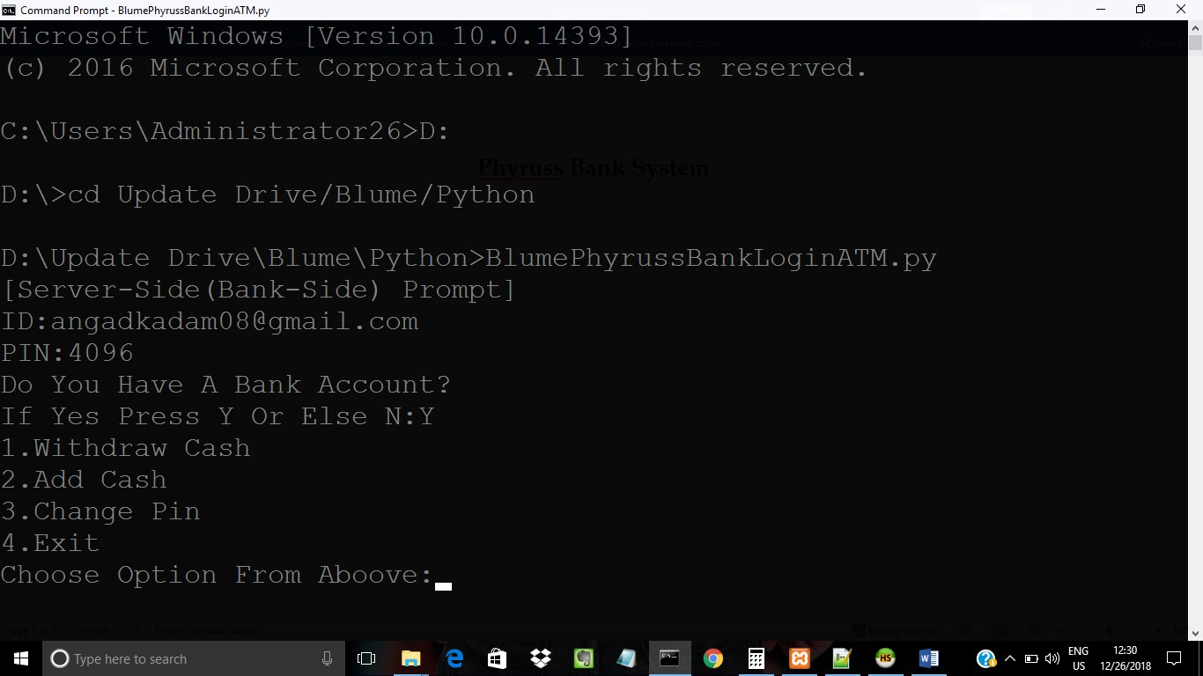

(Fig.1)

1.This Is The Home Page Where Services Are

Started By Authentication And Initialization By Server Side[Optionally Kept To Access The

Databases Credentials].After The Credentials Are

Authenticated And Validated,The System Asks

The User About Bank Account

a) If User has No Bank Account The User Inputs

N or n And Registers Itself to Bank. As

Shown In Below (Fig. 1.1) And Details Are

# Added To Database Shown in (Fig. 1.2) And

Transaction Amount Added Is Recorded In Activity database As Shown In (Fig. 1.3)

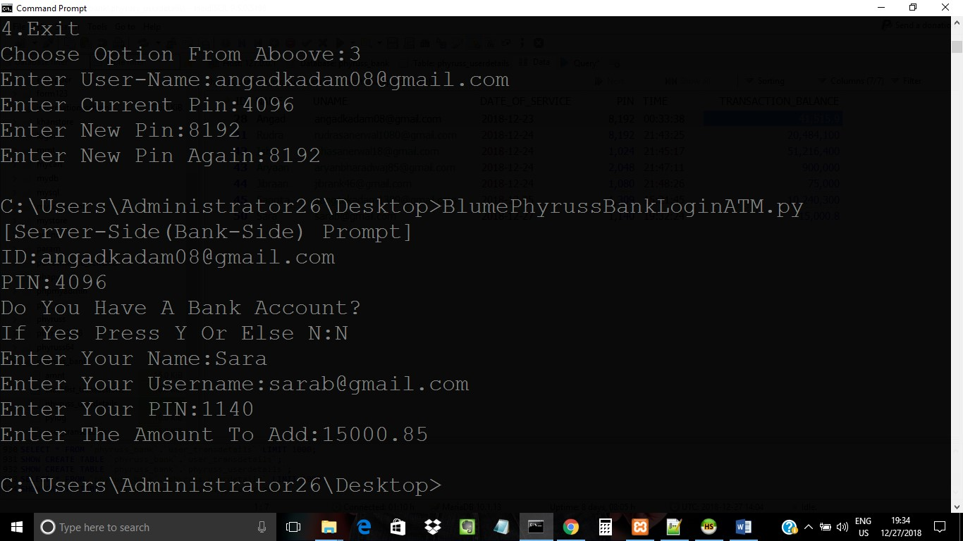

# (Fig. 1.1)

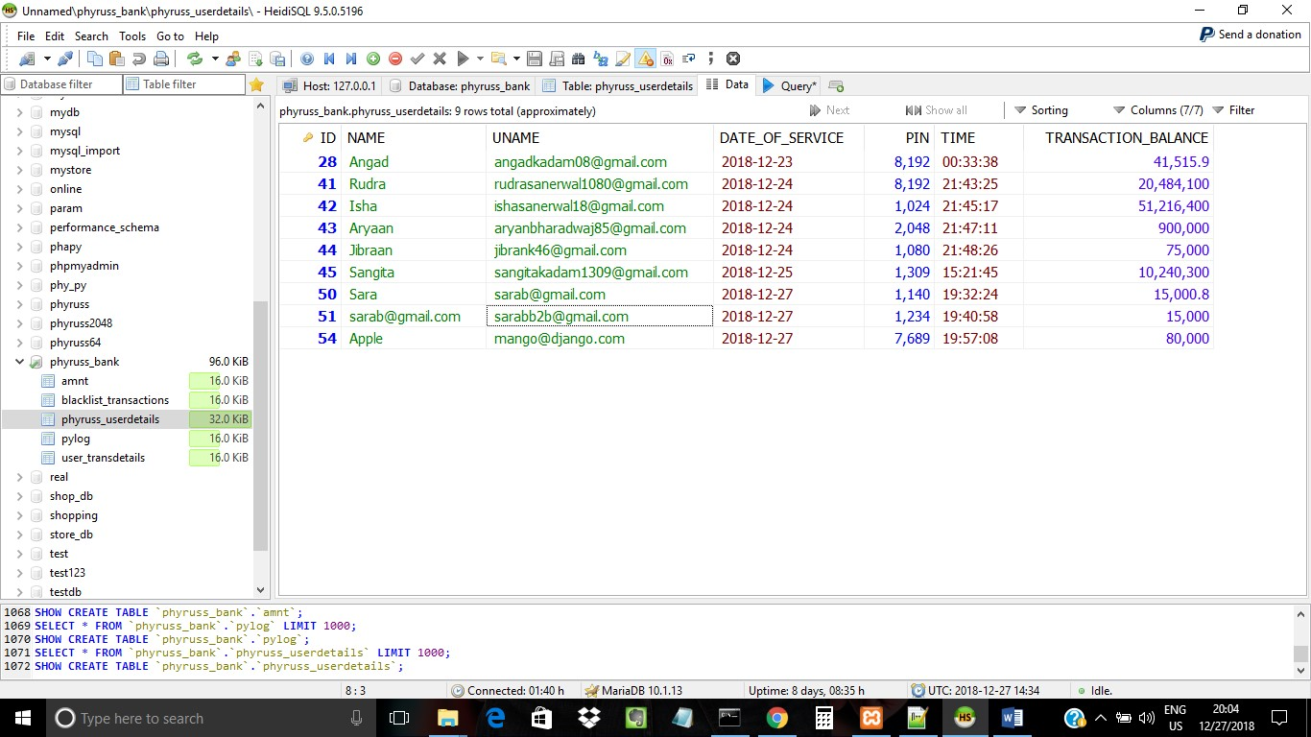

# (Fig. 1.2)

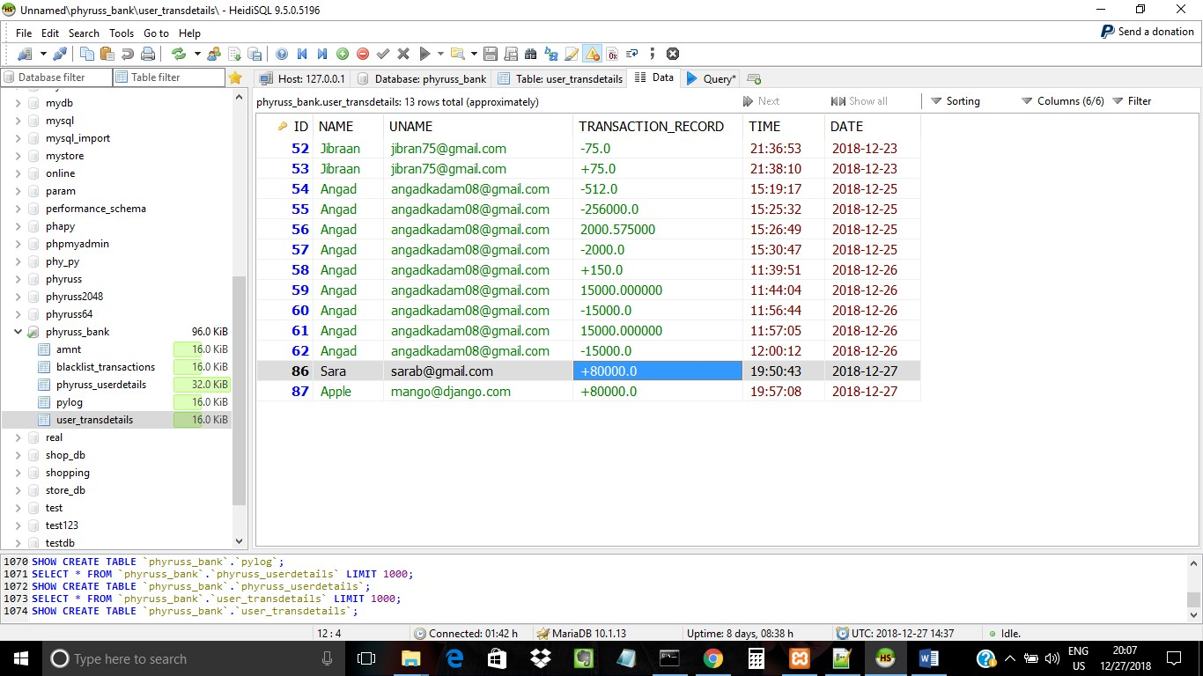

# (Fig. 1.3)

2.The Home Page Shows The Different Options A User Can Choose When He Is Logged In.

3.Lets Go In Detail With One By One.

# Withdraw Cash:-

i. When This Option is Called And Clicked, The System Again Verifies Official Credentials With Database.

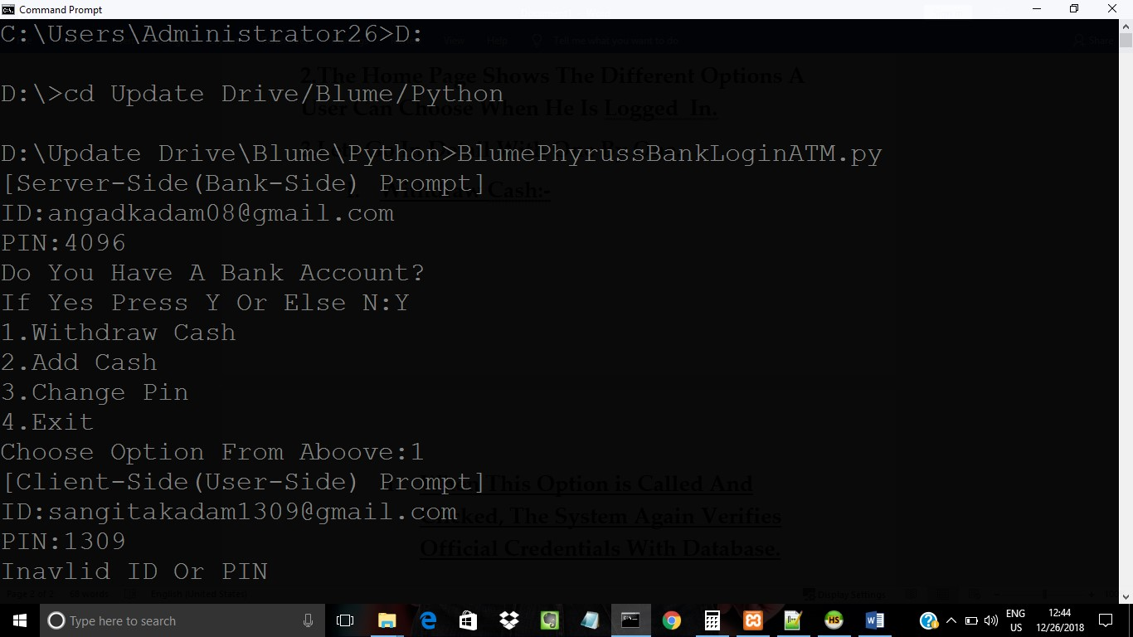

## (Fig.2) ii. The (Fig.2) Shows When The

Credentials Are Entered The Server

Id Mismatches With Official Id And

Pin As The Official Credentials Are

[angadkadam08@gmail.com,4096] As Shown In Below (Fig.3) Database where ID=28(First Row)

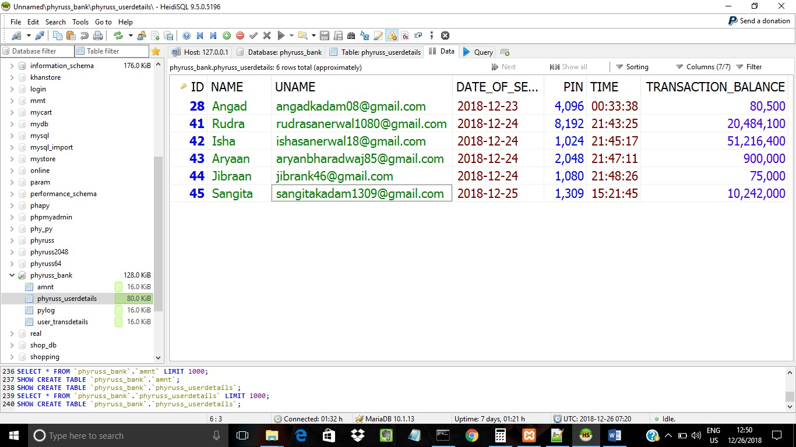

## (Fig.3)

iii. So When Correct Credentials Are

Given The System Proovides Access

To The Bank Session As Shown In

(Fig.4) Refereing (Fig.3)

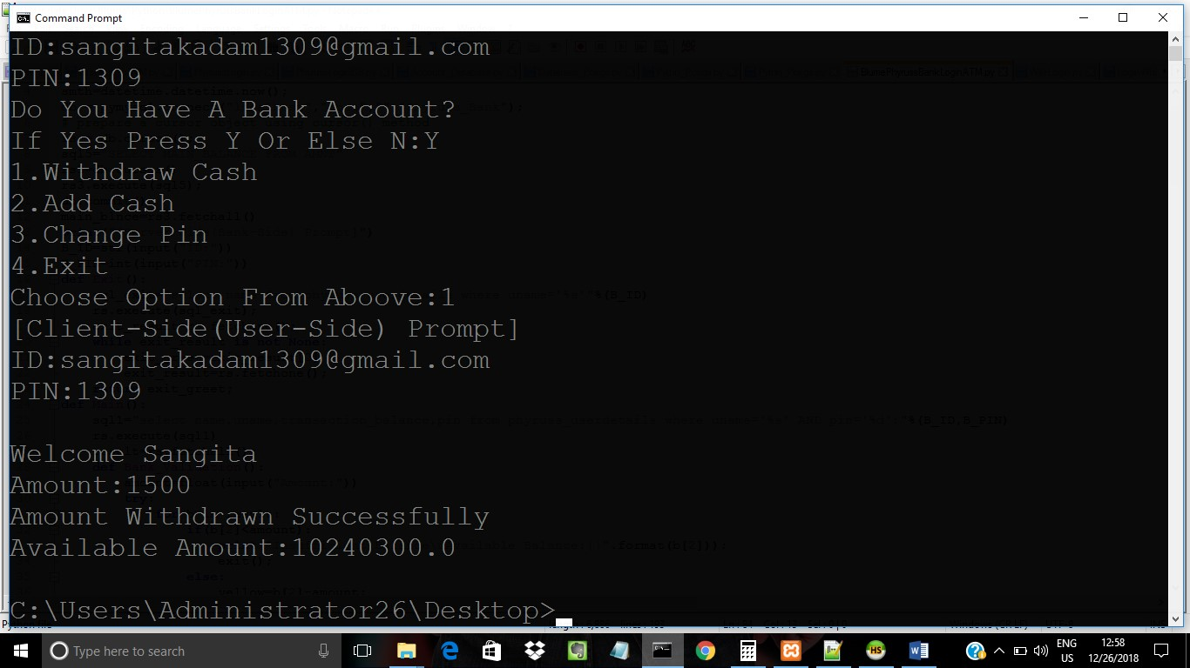

## (Fig.4)

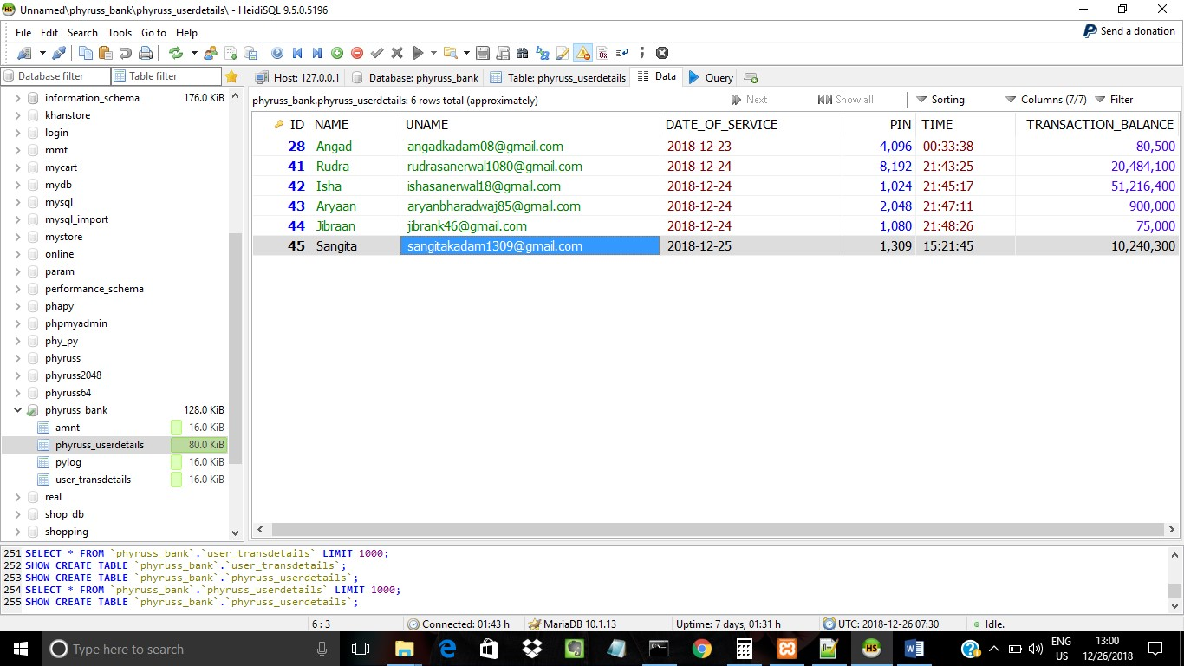

## (Fig. 4.1)

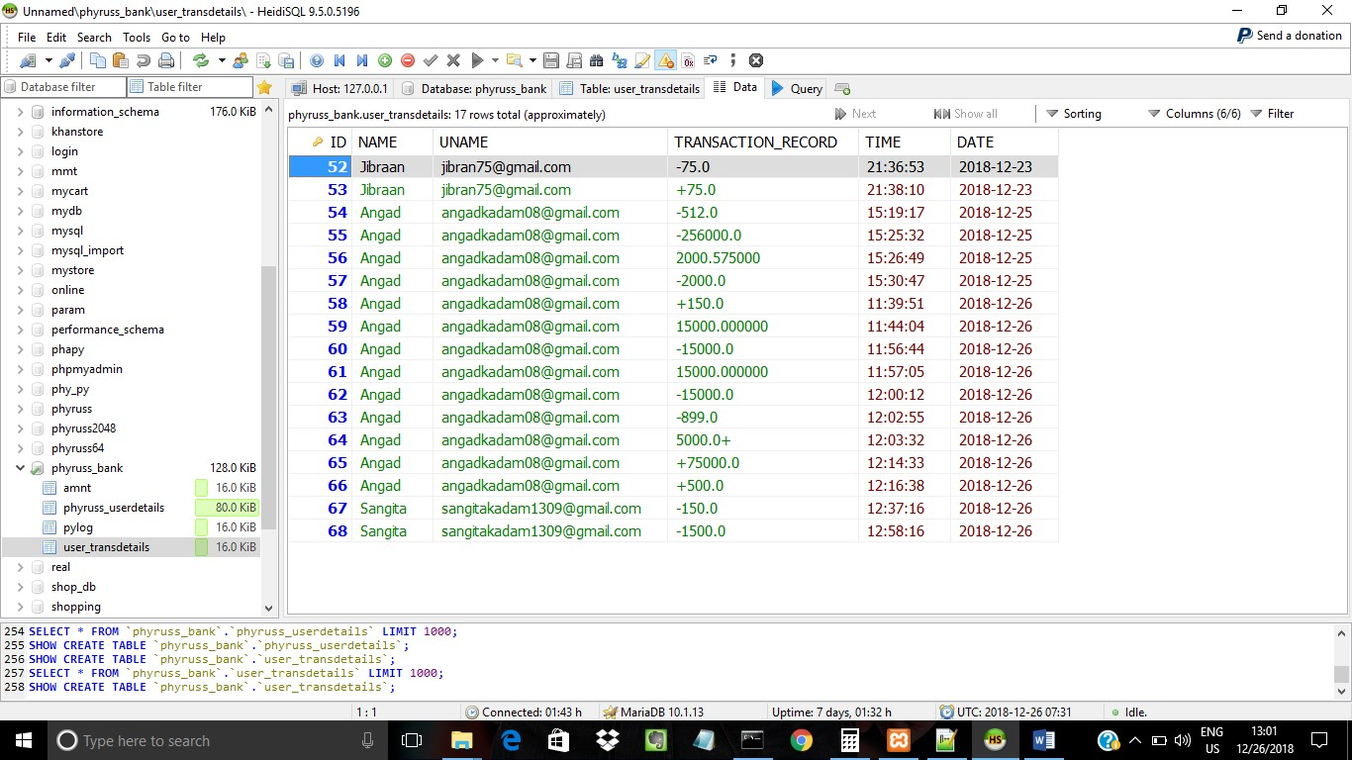

## (Fig. 4.2)

1. As Shown In (Fig. 4.1) And (Fig. 4.2)

The Amount Is Deducted From Users

Account Which goes From

10,241,800->10,240,300.The Deducted

1500 Are Recorded In

User_Transdetails Database To Keep The Track Of User.

1. Now When The User Tries To Enter

The Pin Beyond 4 characters It

Should Technically Prompt Invalid

But For the Sake Of Validation We

Took Double Verification i.e Server

And Client Side Verification To Show The Validation.Lets Understand This By (Fig.5).

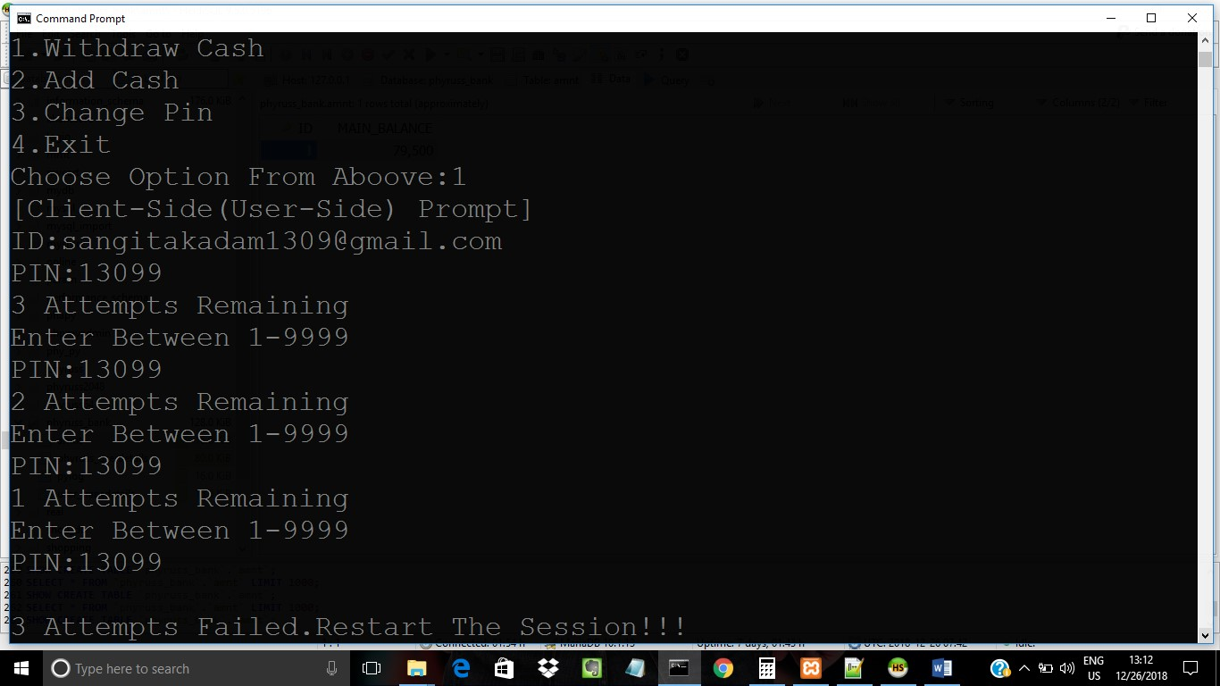

(Fig.5)

1. The (Fig.5) Shows How It Proovides 3 trials To Enter A Pin When User Enter More Than 4 Characters. vii. The System Gives Access To User

But Records It In Blacklist When When The Pin Is Entered In Reversed Pattern.

## As Shown In (Fig.6 And Fig. 6.1)

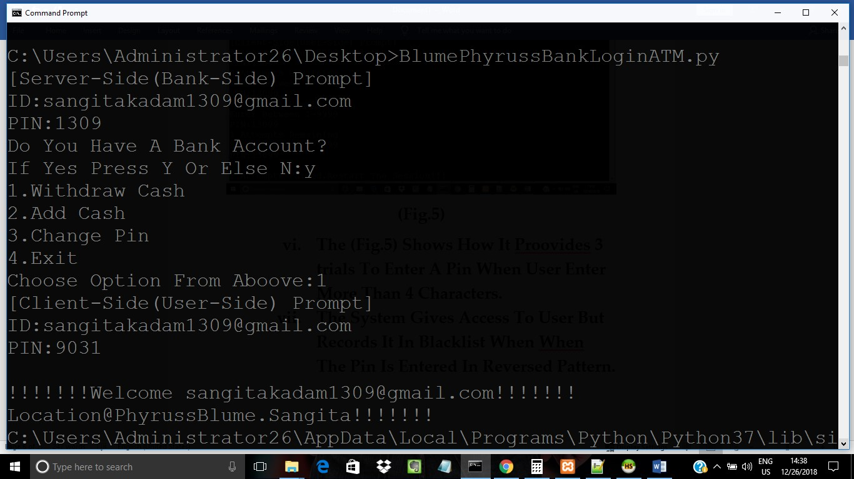

## (Fig.6)

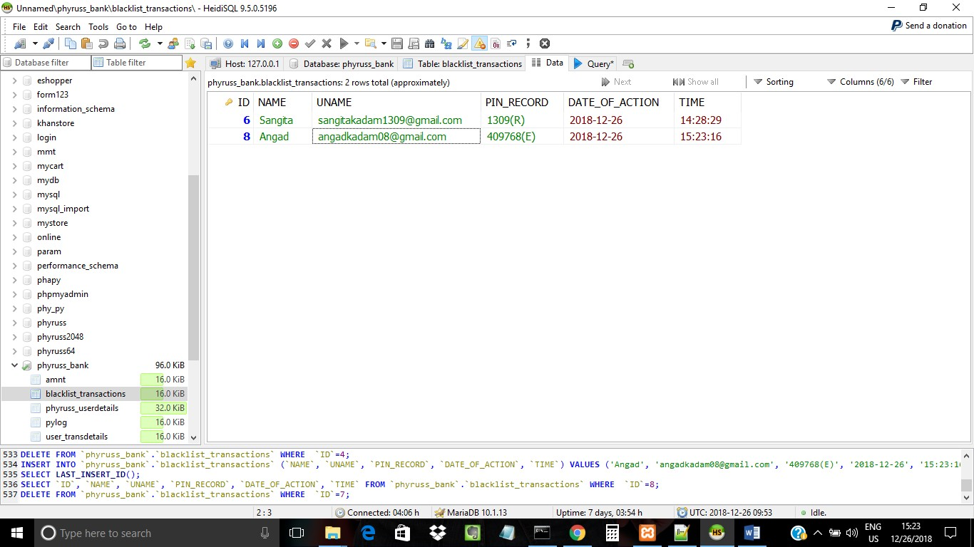

## (Fig. 6.1)

III.Check Balance:

i. When This Option Is Called,It

Prompts The User To Enter Its

Authentication Details As Shown In

(Fig.7)

iii. This Also Includes Validation Of

More Than 4 Characters And

Reverse Pins.The Activity Is

Recorded In Blacklist Database As

Shown In (Fig. 7.1)

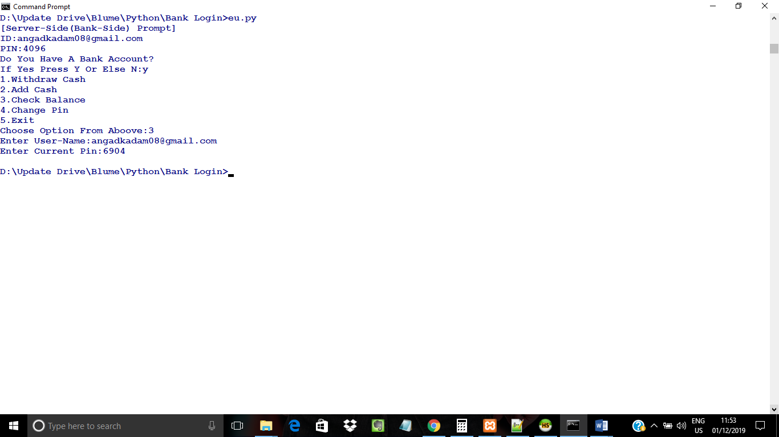

(Fig.7)

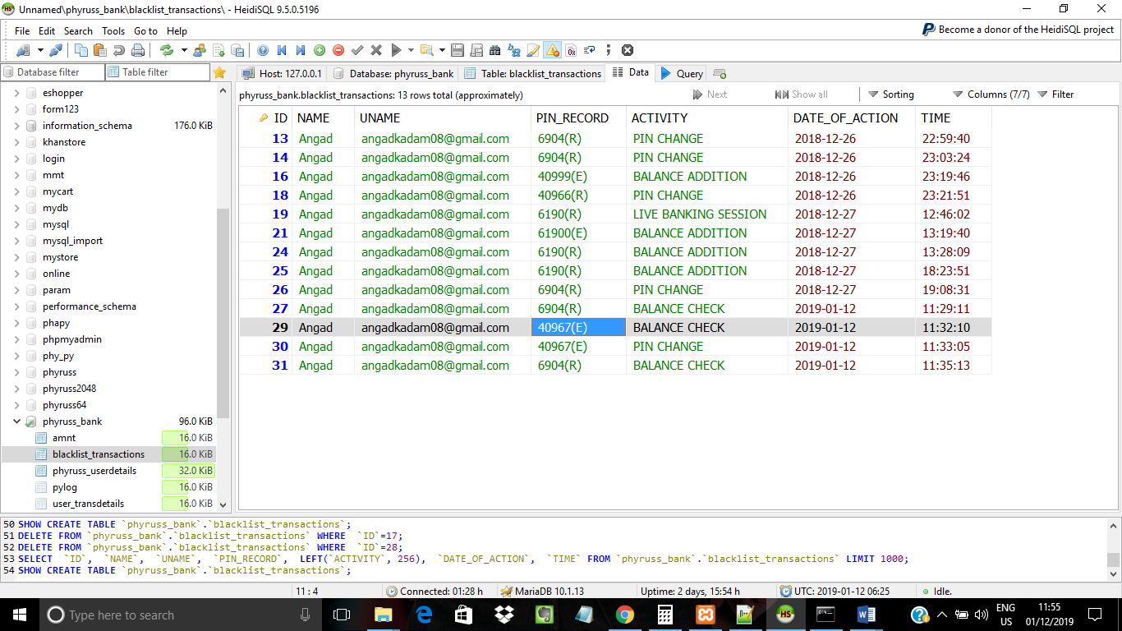

(Fig. 7.1)

IV. Add Cash:

i. When This Option Is Called,It

Prompts The User To Enter Its

Authentication Details As Shown In

(Fig.8)

ii. After Valid Authentication The User

Can Add The Cash In The Bank

Account Which Is Deducted From

Bank’s Available Databse As Shown

In (Fig. 8.1) And Deposited In User’s

Account And Transaction Is Updated In Both Database As Shown In (Fig.

8.1) And (Fig. 8.2) .

iii. This Also Includes Validation Of

More Than 4 Characters And

Reverse Pins.The Activity Is

Recorded In Blacklist Database As

Shown In (Fig. 8.3)

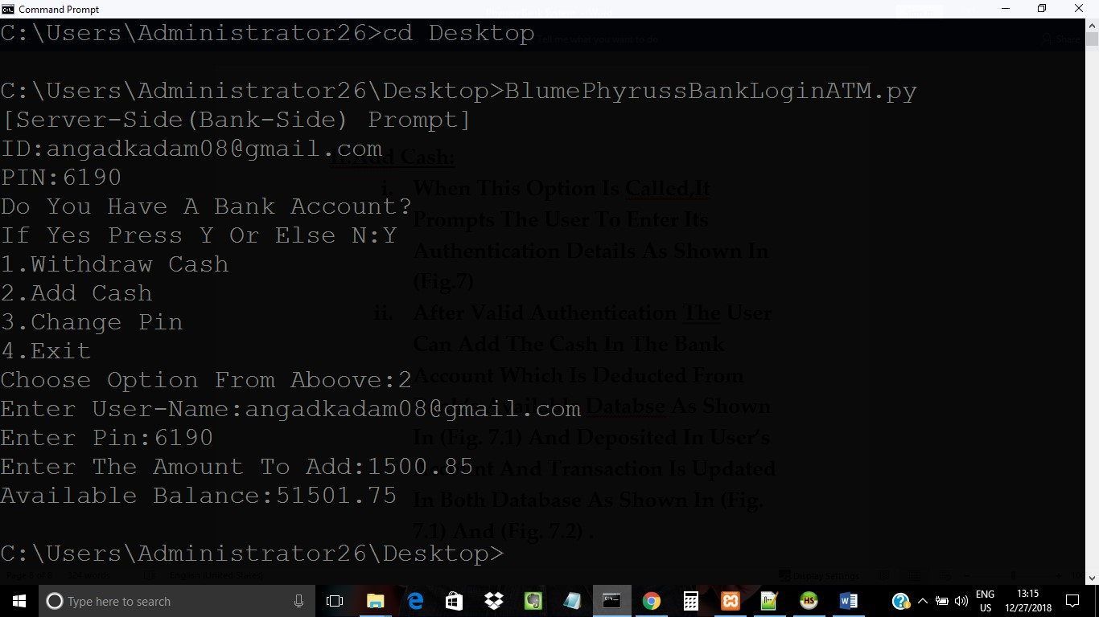

(Fig.8)

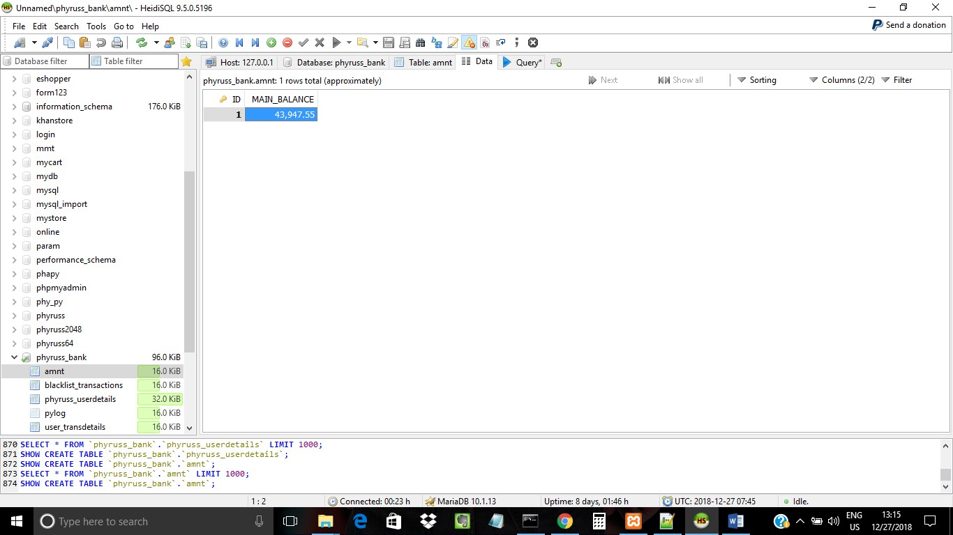

(Fig. 8.1)

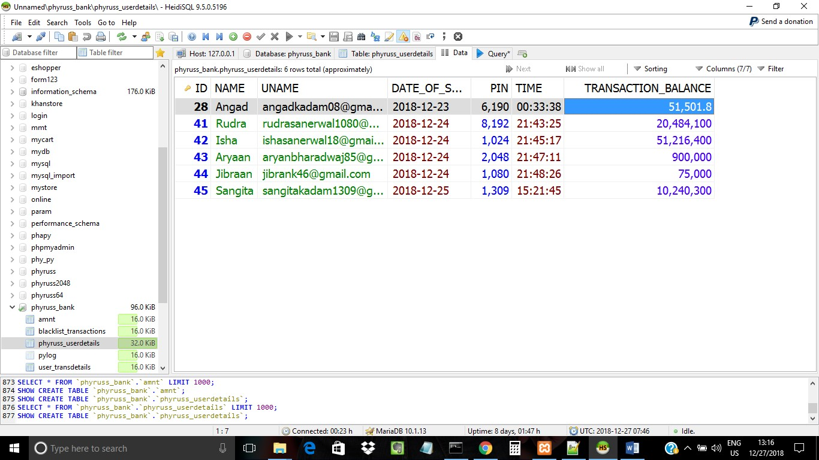

## (Fig. 8.2)

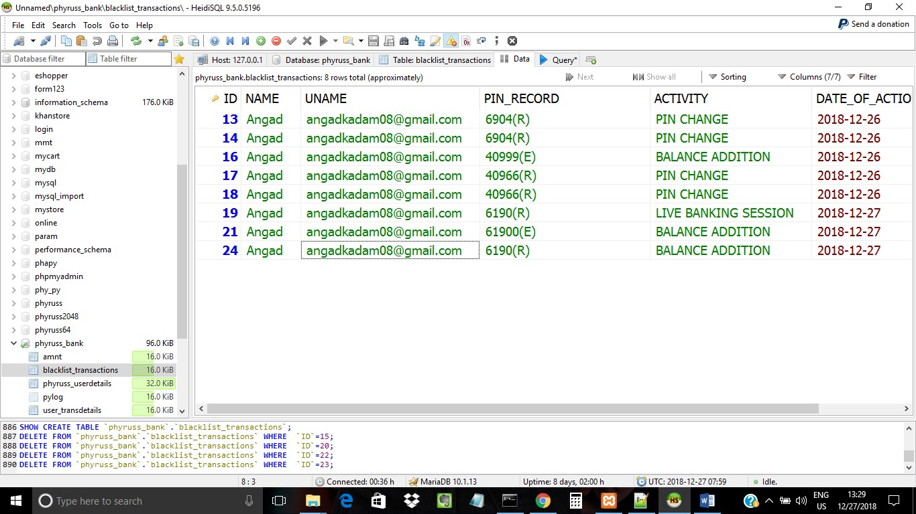

## (Fig. 8.3)

V. Change Pin:

1. When This Function Is Called,The System Invokes The Authentiaction Panel To User To Validate Itself.
2. As We Know That System Takes

Username And Password And

Verifies Itself With Database iii. In This User Has To Enter The The

New Pin To Verify It And Change The

## Pin As Mentioned In (Fig.9)

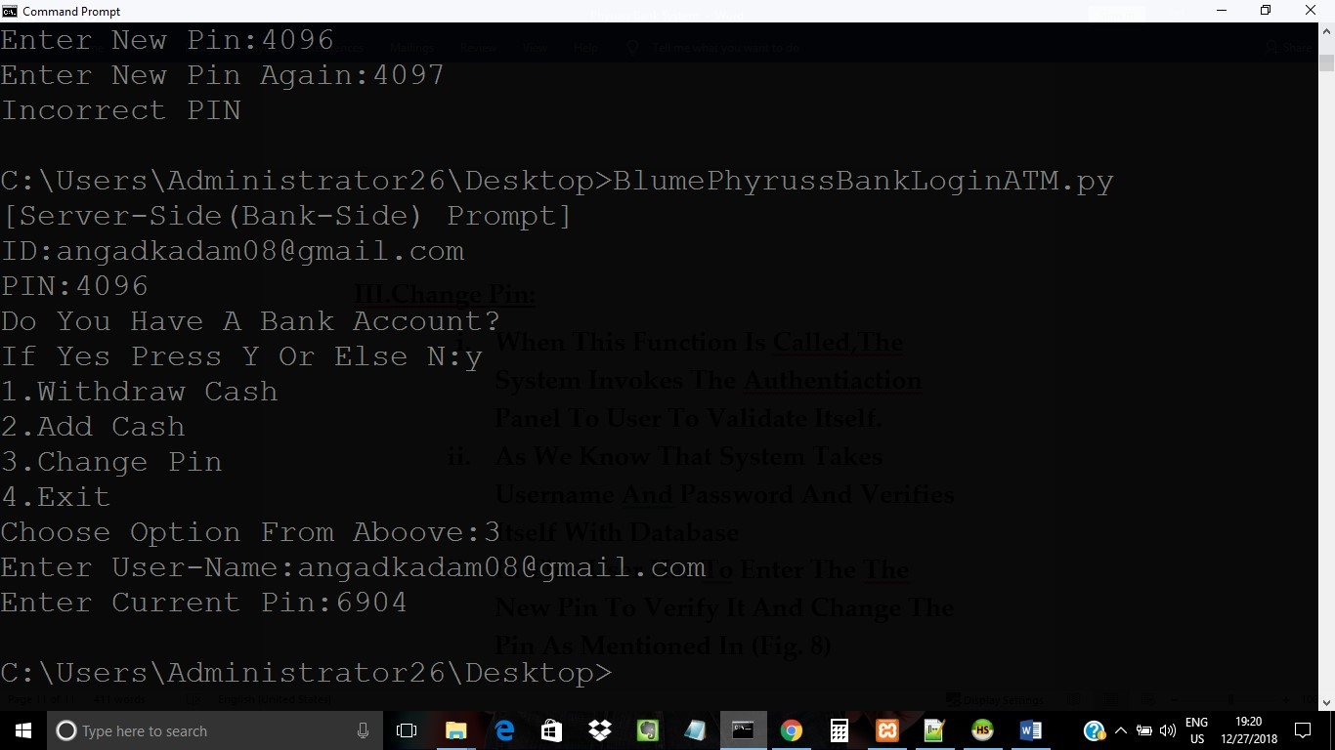

(Fig.8)

iv.Lets Take An Eg:-When The User

## Changes The Pin The The The Database

Checks The Old Pin And Modifies The Value With New Pin As Mentioned In (Fig. 9.1) With Old Pin And (Fig. 8.2) With New Pin.

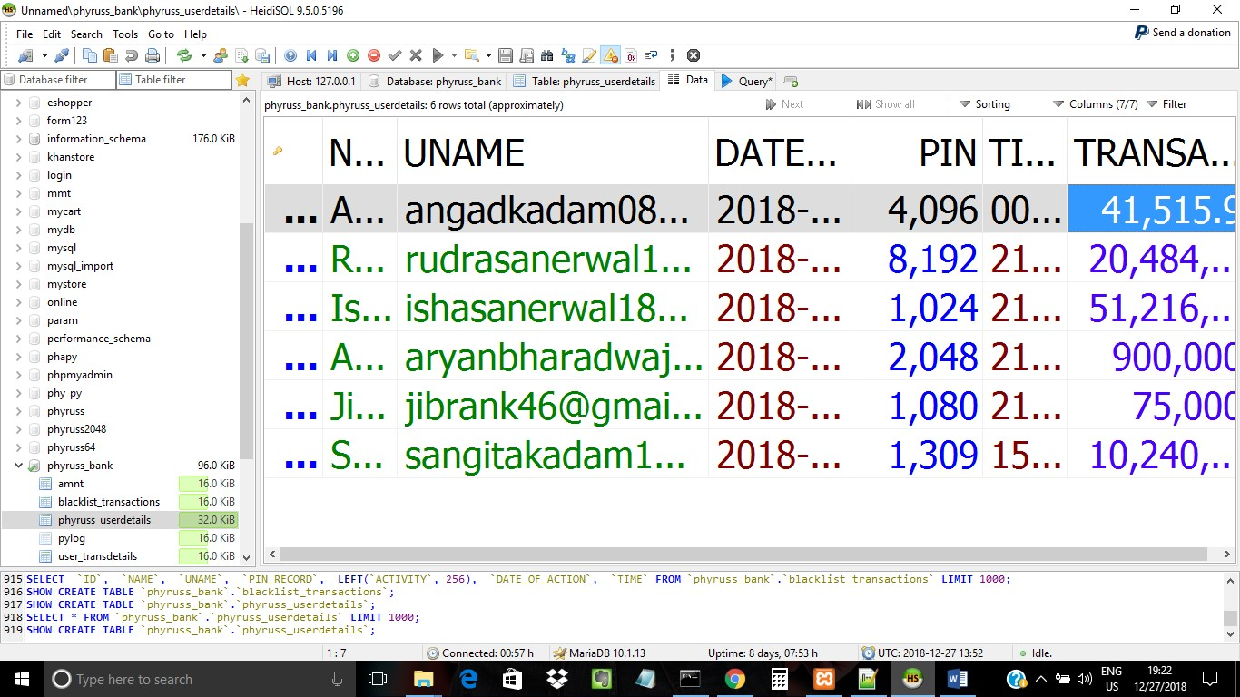

## (Fig. 9.1)

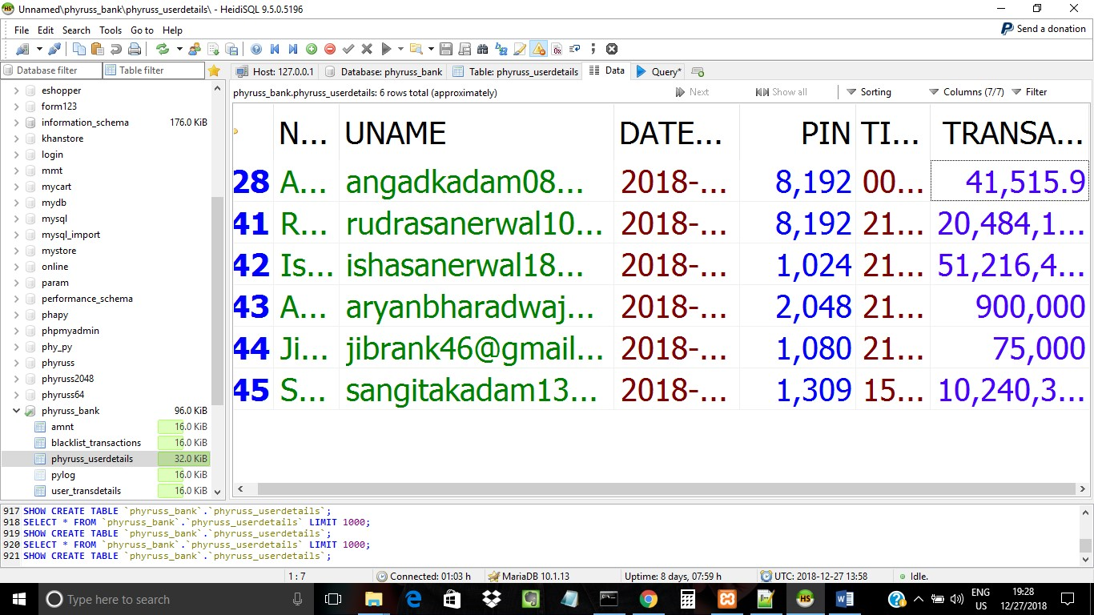

## (Fig. 8.2)

VI. Unique Agenda:

a. To Proovide Security Via Reverse Pin

Facility

## b. To Validate More Than 4 Characters

c. Enhance Addition Of Account On Live Session

VII. Conclusion:By Analysing ATM Banking Process,Research Says That The Banks

Need Encryption At Both Server And End Side.By Studying The Banking System We Come To Call This Task Finished.

|  |  |
| --- | --- |
|  |  |
| Rudra Sanerwal | Angad Kadam |
| (Designer) | (Coding&Devlopment) |